Supermarket Analysis
Project Report
Introduction
Data analysis plays a vital role in understanding business performance and customer behavior. Supermarkets generate large volumes of transactional data daily, which can be analyzed to improve sales strategies and customer satisfaction.
This project focuses on analyzing supermarket sales data using Power BI. The objective is to extract useful insights such as sales trends, customer preferences, and payment behaviors through an interactive dashboard.

Dataset Description
The dataset contains supermarket transaction data, including product line, quantity, total sales, customer type, gender, payment method, and city. It provides detailed information about sales performance across different categories.
The dataset was cleaned and transformed in Power BI to ensure accurate analysis. Additional fields such as monthly sales were derived for trend analysis.

Data Analysis and Visualization
The dashboard includes key performance indicators such as total sales, total quantity sold, and average sales value.
Sales distribution by product line highlights the most popular products. City-wise analysis shows which locations generate the highest revenue. Gender-based analysis provides insights into customer demographics.
Monthly sales trends illustrate how sales vary over time. Payment method analysis shows customer preferences for payment options. The top five products chart highlights the best-performing products.

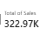
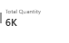
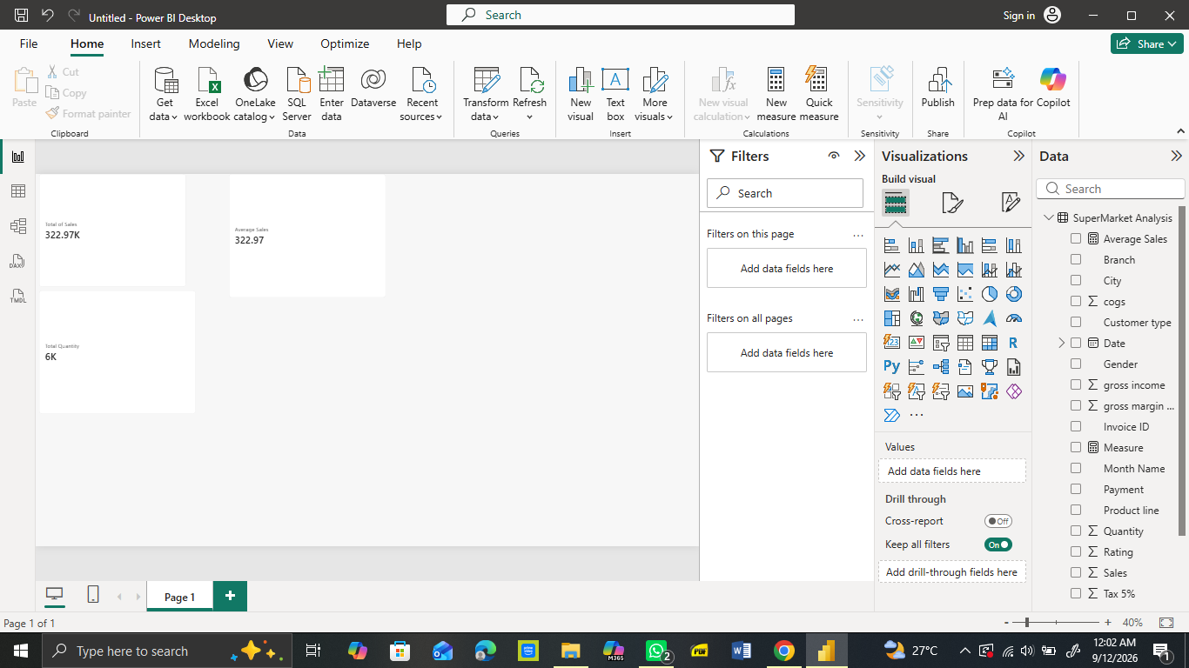
Figure 1:Total Sales Figure 2: Total Quantity Figure 3: Average Sales

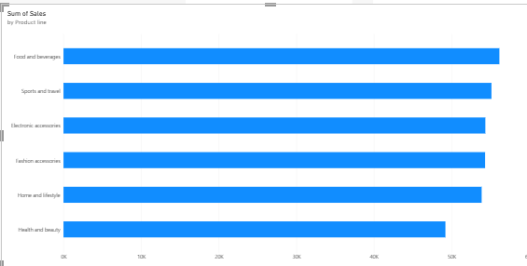
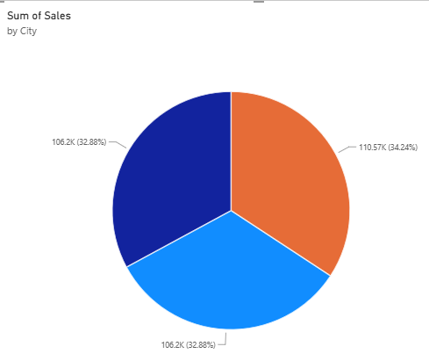

Figure 4: Sales by Product Line Figure 5: Sales by City

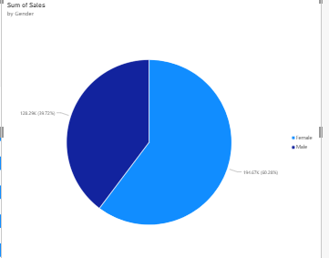
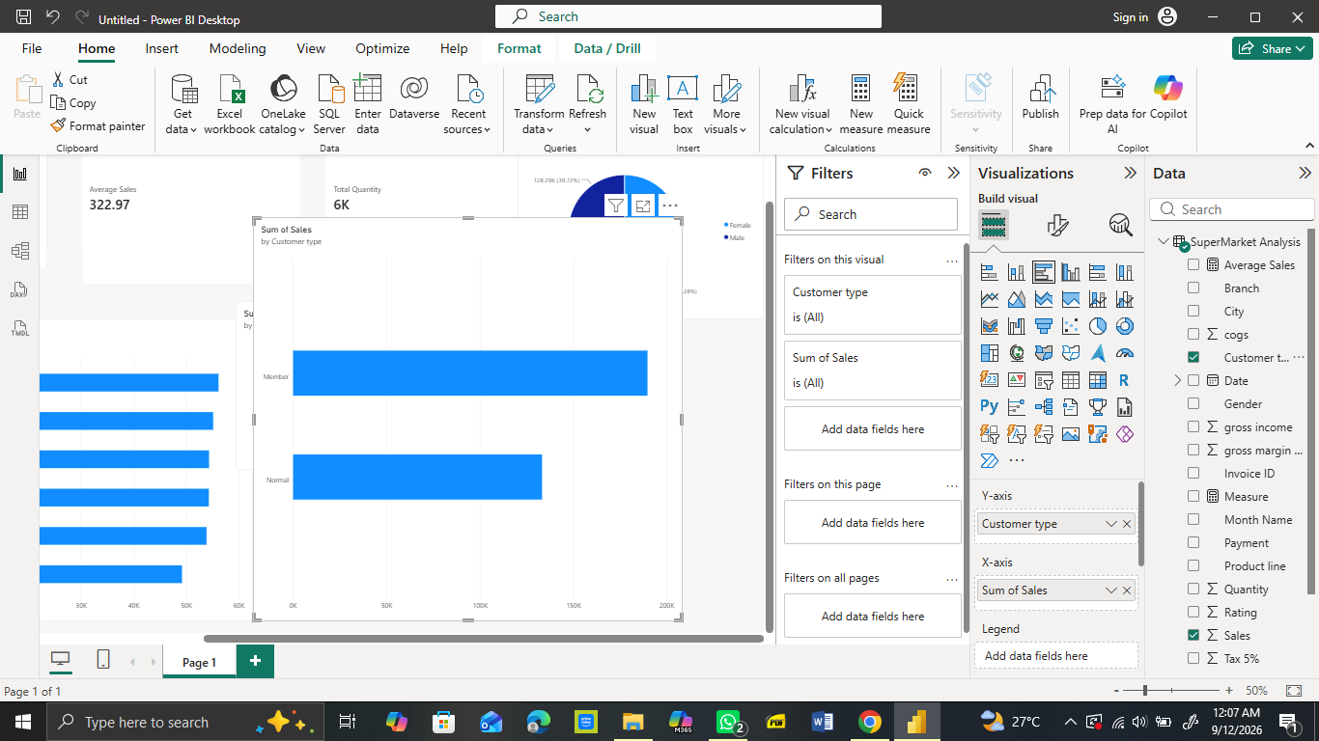
Figure 6: Sales by Gender Figure 7: Sales by Customer Type

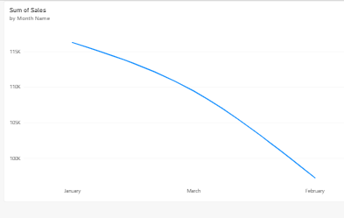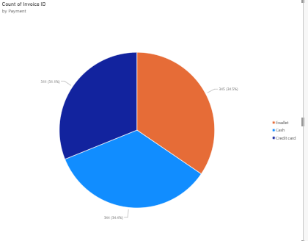
Figure 8: Monthly Sales Trend Figure 9: Payment Method Analysis

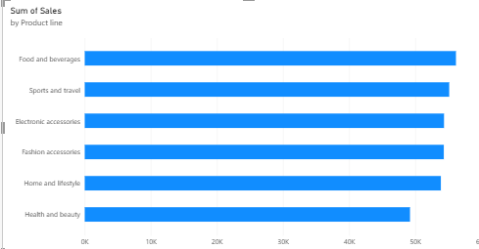
Figure 10: Top 5 Products

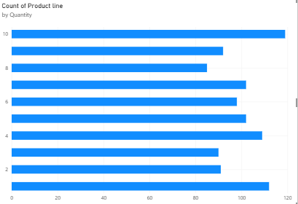

Figure 11: Quantity Sold by Product

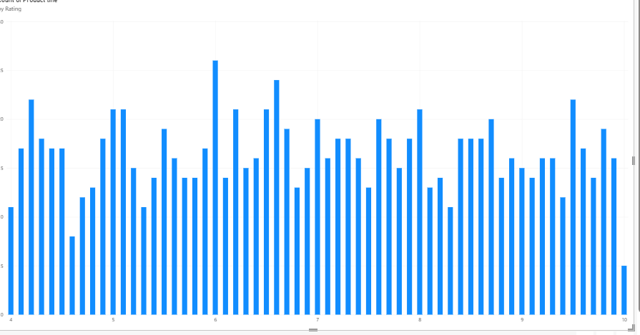
Figure 12: Rating Analysis

Insights and Conclusion
The analysis reveals that certain product lines generate significantly higher sales compared to others. Customer purchasing behavior varies by gender and location.
Monthly trends indicate fluctuations in sales, suggesting seasonal demand patterns. Payment methods such as cash and digital payments are commonly used by customers.
Overall, the dashboard provides valuable insights into supermarket operations, helping businesses improve decision-making, optimize inventory, and enhance customer satisfaction.
In conclusion, Power BI proves to be an effective tool for transforming raw data into meaningful visual insights for business growth.

